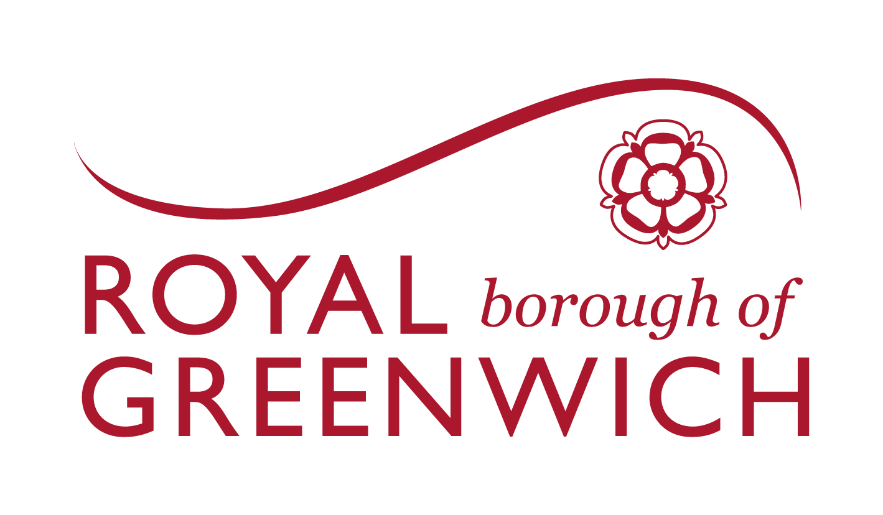

Application Form

1 April 2027 – 31 March 2031

Voluntary, Community and Faith Sector GRANTS (VCFS)

The Royal Borough of Greenwich is committed to working in genuine partnership with the Voluntary, Community and Faith Sector to improve outcomes for residents, promote equity and support fairer, healthier and more connected communities. We recognise the vital role that voluntary, community and faith organisations play in delivering trusted local services, strengthening community resilience and supporting the residents of Greenwich.

BEFORE YOU BEGIN TO WRITE YOUR FUNDING PROPOSAL, PLEASE:
- Ensure that you are eligible to apply for funding by referring to the Prospectus Criteria.
- Note the deadline for submitting the funding proposal is 5pm on Monday 26 October 2026. Proposals received after this date and time will not be accepted.
- Read through the details of the Prospectus and expected outcomes and Application Guidance document before applying.
- We advise you to complete this application on a larger device than a phone, but please contact VCS-Grants@royalgreenwich.gov.uk if you have any access issues. You can also download the application, complete it offline, and then upload it to the Plinth system.
- Individual applicants and the Lead Organisation of any consortium/partnership must complete all sections of the application form and the financial tables provided.
Please submit any clarification questions to VCS-Grants@royalgreenwich.gov.uk

Documentation required

You will be required to attach the following supporting documents, policies and procedures at the end of your application.

- Organisation’s Governing Document
- Safeguarding Policy and Safeguarding Children Policy (if your organisation directly delivers a service for children and/or young people)
- Public Liability Insurance Certificate
- A Statement of Intent for consortia bids signed by all partners (if applicable)
- Financial Procedures Policy
- Equal Opportunity and Diversity Policy
- Whistleblowing Policy (if separate from the safeguarding policy)

You will also need to upload:

- Completed Budget Template
- Audited accounts for the last two years. If these are not available an alternative means of demonstrating financial status will be required, e.g. independently examined accounts.
- Financial Sustainability Document

Section 1 – About your Organisation

Which funding stream are you applying for?
Choose an item.

Project title: Click or tap here to enter text.

Organisation and Contact Details
Organisation Name
Name of Main Contact
Position or Job Title
Email address
Telephone number
Mobile number
Postal Address
Is your organisation based in the Royal Borough of Greenwich?
Website:
Does your main contact have any specific communication needs that we should be aware of? e.g. braille, large print or sign language?

2 Legal Status
When was your organisation set up?
Is your organisation not-for-profit?
When did your organisation adopt its current legal status?
What type of not-for-profit is your organisation? (Charity/CIC/CIO/social enterprise, etc.)
Registered charity? | Charity number:
Company Limited by Guarantee? | Company number:
Other legal status details (if applicable):
Does your organisation have a UK bank account?
Is your organisation registered for VAT?
Registration Number with appropriate bodies, e.g. Ofsted, CQC (if applicable)

3 Partnership / Consortia
Only the lead applicant of a consortium or partnership needs to submit an application. Additional information about partner organisations may be required at a later stage.
If this is a joint application, please list the other organisations that are part of the formal partnership/consortium.
Name of organisation | Address of organisation | Organisation’s status

Partnership / Consortia – Lead partner only to complete
If you are applying as a Partnership or Consortia, please attach your Memorandum of Understanding/Agreement or Partnership Agreement.

If this is a Partnership/Consortium application, please describe the operational and administrative arrangement of the partnership. [Up to 500 words]

4 Staffing
How many permanent staff do you have?
How many volunteers does your organisation have?

5 London Living Wage
Are you a London Living Wage employer? Yes/No (delete as appropriate)
If not, what steps are you taking towards becoming one?

6 Information Sharing and Security
Is your organisation registered on the Data Protection Register with the Information Commissioner’s Office? Yes/No
Please explain how you ensure information held by your organisation is appropriately shared and stored (i.e. how you are GDPR compliant).

7 Equal Opportunities

Do you have an Equal Opportunities and Diversity Policy, or relevant documentation, setting out your organisation’s understanding of, and approach to, its obligations under the Equality Act 2010?

Yes/No

8 Your Trustees
Do any of the following statements apply to your organisation, or to any of the Directors, Trustees, Partners or owners? (Please delete as appropriate)
- Has each member of your Board/Management Committee signed a declaration to confirm that they are eligible to serve as a Trustee/MC Member and that they meet the Charity Commission’s ‘Fit and Proper Person’ test? Yes/No
- Are any persons involved in your organisation related to, or have a close association with, any Trustee/Management/Staff and/or volunteers? Yes/No
- Have any of your Board, Trustees, etc. committed an act of serious misconduct in the course of business? Yes/No
- Within the last five years have any complaints been upheld against your organisation to any professional body? Yes/No
- Has your organisation been in a state of bankruptcy, insolvency, compulsory winding up or receivership, or does it have arrangements with creditors? Yes/No
- Have any of your Board, Trustees, etc. been convicted of a criminal offence related to business or professional conduct? Yes/No

If you have answered yes for any of the questions above, please provide details.

Section 2 – Quality Assessment Questions
- Project Proposal
Please tell us in detail about the activity/programme you are applying for.

Your response should include:
- A demonstration of your relevant experience of delivering the proposed activity/programme or similar services.
- An explanation of whether the activity is new or an existing delivery, with appropriate context, including any evidence of demand or previous success where relevant.
- Why the activity/programme is needed and how it responds to an identified local need.
- A clear and comprehensive explanation of what will be delivered, including the main activities, how they will be delivered and what users will experience.
- Clear information on where activities will take place and how often they will be delivered. Delivery arrangements are realistic and appropriate.
- A clear approach to co-design and involving people with lived experience in the design, delivery and ongoing development of interventions.
- An approach that ensures the activity/programme is accessible, relevant, responsive and trusted, particularly by residents who may face barriers to participation.
- The intended beneficiaries are clearly identified, including who the activity is for, why they have been chosen and the number of people expected to be reached, with a proposed reach that is realistic and proportionate to the funding requested.

(Maximum 1000 words)
Scored out of 5
Weighting 25%
Provide response here:

- Staffing and Project Management
Please describe how you intend to staff, manage and deliver the activity/programme. Include details of the people, skills, resources and partnerships that will enable you to deliver the project successfully.
Think about how you can show:
- Appropriate staffing and recruitment arrangements are in place, with clearly defined roles, responsibilities and adaptability to manage demand.
- Staff and volunteers have the relevant skills, qualifications and experience to deliver the proposed activity/programme.
- Clear management arrangements that demonstrate effective oversight, accountability and decision-making.
- Robust safeguarding arrangements are in place to prevent, identify and respond to abuse, neglect, exploitation and self-neglect, including clear policies, appropriate staff and volunteer checks, training and defined routes for reporting and escalation.
- Robust processes are in place to monitor performance, maintain quality and drive continuous improvement.
- The organisation demonstrates effective collaboration with statutory services, community organisations and other partners to provide appropriate referrals and respond to residents’ needs.
- A realistic and achievable mobilisation plan is in place, showing readiness to commence delivery by April 2027.
- Appropriate contingency arrangements are in place to minimise the impact of programme disruption or failure.

You may submit an organisational structure chart to support your application (optional).

Responses should include details of proposed staffing structures, management arrangements including TUPE (if applicable).

(Maximum 1000 words)

Scored out of 5
Weighting 25%
Provide response here:

- Outcomes, Monitoring and Social Impact
Please explain how you will achieve and monitor the expected outcomes set out in the Prospectus. Your response should include evidence of the wider social impact you will generate.
Your response should include:
- How the activity/programme will contribute to the chosen priority outcomes set out in the prospectus.
- Clear and realistic outcomes are identified for residents, with a logical link between the proposed activities and the expected benefits.
- How you have a proportionate approach to monitoring progress, measuring outcomes and evaluating the effectiveness of the activity/programme.
- Appropriate methods are in place to collect, manage and report data, with suitable evidence to demonstrate outcomes.
- The wider social, economic or environmental benefits the activity/programme will generate for the local community beyond the direct project outputs.
- How monitoring, feedback and learning will be used to improve delivery and maximise impact throughout the funding period.

(Maximum 1000 words)
Scored out of 5
Weighting 30%
Provide response here:

- Financing your Proposal
Please outline how you intend to finance your project/activity and what you plan to spend the money on. We know that circumstances can change, so be as realistic as possible.

We will be assessing:
- Are the costs eligible?
- Are they reasonable and proportionate?
- Do they represent good value for money?
- Does the budget align with the proposed activity?

(Please complete the Budget Template.)

Scored out of 5
Weighting 20%
Provide response here:

Section 3 – Financial and Organisational Due Diligence

1 Governance and Financial Management

Please outline your organisation’s governance and financial management arrangements.
Your response should include:
Governance
- Your organisation’s aims and objectives.
- The structure of your Board or governing body.
- The skills, experience and expertise of your trustees, directors or committee members.
- Whether there has been significant leadership turnover.
- How your Board provides strategic oversight and monitors organisational performance.
Financial management
- Who is responsible for overseeing the organisation’s finances.
- How financial decisions are authorised and monitored.
- The financial controls you have in place.

2 Funding and Service Delivery Performance

Please outline any issues that have arisen from any previous funding and service delivery.

This includes any agreements that may have ended because of poor performance, Charity Commission investigation, or court actions taken against the organisation, including any significant employment tribunal hearings in the last five years.

Please include any actions taken by your organisation to address these issues and the improvements that have been implemented [Up to 300 words]

3 Audited Accounts

Please attach your last two years’ Audited or Independently Examined Accounts. If your organisation was set up less than three years ago, please provide all the Audited or Independently Examined Accounts you have to date.

4 Amount Requested

Please indicate the total amount of funding you are seeking from the Royal Borough of Greenwich:
£ ……………

Will the amount of funding sought be your principal source of income? Yes/No

Is this funding contributing to, or fully covering, the cost of your service? Yes/No

If contributing, what percentage will this funding be of your total income? ……%

Have you or are you applying for any other funding from the Royal Borough of Greenwich (e.g. Next Gen, Greenwich Neighbourhood Growth Fund, Neighbourhoods Fund) in the last 12 months?

If so, which funding have you applied for?

Were you successful in your application (if results known at this time)?

If successful, how much funding did you receive?

5 Financial Sustainability over the next four years

We need to be assured that the funded service will be financially sustainable throughout the term of the funding period and that it represents good value for money.

Please complete the Financial Sustainability Document for the next four years.

Please find the template at royalgreenwich.gov.uk/vcfs-grants

6 Reserves

How much does your organisation currently hold in Reserves?
(Unrestricted / Restricted or both)

What are your current Reserves being held for?

Please outline your Reserves policy.

7 Safeguarding

Please refer to the Guidance Notes for details, including specific safeguarding requirements for Children’s and Adults’ Services and Safer Recruitment Advice in Appendices A, B, C and D.
Do you have an up-to-date Safeguarding Policy? Yes/No

8 Referees
Please provide contact details for two referees from funders. Please see the Guidance Notes for more information.
Reference 1
Name of organisation:
Referee name:
Referee’s phone number:
Referee’s email address:
Funding description:
Funding date and period:
Value:

Reference 2
Name of organisation:
Referee name:
Referee’s phone number:
Referee’s email address:
Funding description:
Funding date and period:
Value:

If you are unable to provide two references, please explain why below.

Section 4 – Declaration

When you have completed the application, please ensure an authorised signatory from your organisation signs the declaration, agreeing to the following:
- I am authorised to sign this application on behalf of the applicant organisation.
- All information given in the application is true, and the application has been authorised by our governing body.
- I will inform the Royal Borough of Greenwich of any changes that could affect this application.
- I understand that any funding offer will be subject to agreed, and signed for, terms and conditions.

Name:
Position:
Signature:
Date:

