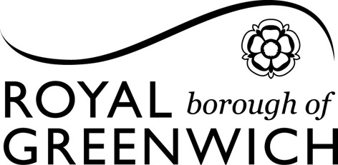
NOTICE OF APPLICATION
Licensing Team, Woolwich Centre, 35 Wellington Street, London, SE18 6HQ.
Tel: 020 8921 8018; Fax: 020 8921 8380; Email: licensing@royalgreenwich.gov.uk
FOR A PREMISES LICENCE - LICENSING ACT 2003

Notice is given that: ………………………………………………(name and address of applicant) has applied for the ………………………………… (grant or variation) of a Premises Licence for the following premises:

A record of this application may be inspected by appointment.

Other persons may make representations to the Council on this application by no later than ……………………………………. (last date for making representations). Representations can be made in writing, by email or fax using the contact details above. Representations can only be made on the grounds of one of the four licensing objectives, namely:

- Protection of children from harm
- Prevention of Public nuisance
- Prevention of crime and disorder
- Public safety.

Any person who makes a false statement in connection with an application is liable on summary conviction to a maximum fine of £5,000.

It is proposed that the following licensable activities will take place at the premises:

………………………………………………………………………………………
………………………………………………………………………………………
………………………………………………………………………………………

