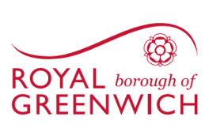

ROYAL BOROUGH OF GREENWICH

TOWN AND COUNTRY PLANNING (GENERAL PERMITTED
DEVELOPMENT) (ENGLAND) ORDER 2015 (AS AMENDED)

PUBLIC NOTICE

CANCELLATION OF DIRECTION MADE UNDER ARTICLE 4(1)

The Royal Borough of Greenwich made a direction under article 4(1) of the Town and Country Planning (General Permitted Development) Order 2015 (as amended) on 3 August 2022.

Notice is hereby given that on 8th August 2023 the Royal Borough of Greenwich confirmed a direction under Article 4 (1) of the Town and Country Planning (General Permitted Development) Order 2015 (as amended) (“the Direction”) (“the GPDO”).

This Direction cancels the Article 4 (1) Direction made on 28th January 2015 which withdrew the permitted development right for change of use from Class B1(a) Office Use to Class C3 Residential for 2-14 Pier Walk, Greenwich, SE10 0ES and 6 Mitre Passage, Greenwich, SE10 0ER. A map showing the areas affected is below

The Direction and the map defining the area to which it relates can be viewed online at Current and proposed directions | Article 4 direction areas | Royal Borough of Greenwich (royalgreenwich.gov.uk)

