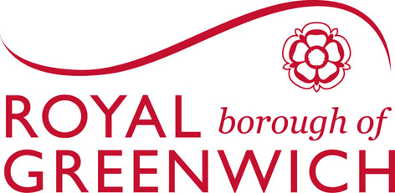

Street Trading

Pavement licence
Application form

Issued under the Levelling-Up and Regeneration Act 2023

Required documentation

Pavement Licence

(Business)

The Royal Borough of Greenwich is under a duty to protect the funds it administers. To this end we may use the information that you have provided for cross-system and cross-authority comparison purposes, for the prevention and detection of fraud.

The following information and documentation is required
- Detailed Plan - This should show the area where you intend to place furniture, including dimensions.
- Public liability insurance – Minimum Cover of £5 million
- Waste disposal / transfer documentation
- Right to occupy - Evidence of your legal right to use the premises (e.g., lease or rental agreement).
- Appropriate Application fee of £500.00 for one year
- Site Consultation Notice
Additional information required for Food Sellers Only
- A Royal Borough of Greenwich Food Handlers Award or Food Handlers Rating Scheme (score of 3 or more)
- Current (less than 5 years old) Foundation Level 2 Food Hygiene Qualification
- Evidence of Food Business registration (unless registered with RBG)
Identification
The applicant must be aged 18 years or over.

Provision to issue Licence under the Levelling-Up and Regeneration Act 2023

- Home Address/Details
Forename/s: | Surname:
Address:
 | Post Code:
Contact No: | Mobile:
National Insurance No:
E-mail:

- Premise Name
Premise Name:
Address:
Post Code:

Comments

Proposed dimension of area:
Width | Depth

(e) Proposed times/days of operation:
DAYS | HOURS From | HOURS  To
Monday
Tuesday
Wednesday
Thursday
Friday
Saturday
Sunday

You are required to supply the following information, so the Royal Borough can properly assess your application. The Royal Borough reserves the right to check upon the information provided.

- Have you ever been convicted of?
Yes |  | No
Yes |  | No
Yes |  | No
Yes |  | No
    - Unlicensed street trading
    - Food hygiene offences
    - Violent behaviour
    - Breach of conditions of Licence

Please note: Before your application can be progressed, we will need to visit your premises to look at the proposed area. We may also need to liaise with other departments including.
- Police
- Licensing
- Highways
- Environmental Health

DECLARATION
I, the undersigned, understand and agree that:

(1) No street trading will take place until such time as the renewal of the Pavement Licence
has been granted for my premises

(2) Any damage to the public highway resulting from your trading activities that requires
repairs to be carried out by the council, will be charged to, and paid for in full by the
permission holder.

(3) Public liability insurance covering a minimum of £5 million shall be in place for the
premises. This Public Liability Insurance must cover for the period in which I occupy the
public highway as required in the conditions.

I (the applicant) confirm that the above details are correct, and acknowledge that the above
must be conducted in accordance with the requirements of the legislative acts and the
associated legislation and codes of practice, together with any other conditions imposed by
the Royal Borough of Greenwich. I also acknowledge the need for me to pay the prescribed
fees that are imposed by the Royal Borough of Greenwich which is non-refundable.

Applicants Signature

Print Name

Date

street-trading@royalgreenwich.gov.uk

