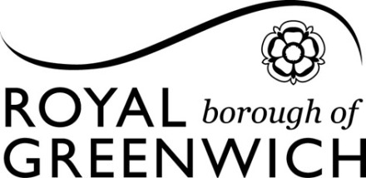

**The Royal Borough of Greenwich**

**_______________________________**

**GREENWICH SUPPORTS**

**WELCOMING SPACES GRANT**

**REQUIREMENTS AND GUIDANCE**

**________________________________**

**AUGUST 2023**

1. **Introduction: Welcoming Spaces Grant**

1.1 The Welcoming Spaces Grant is a fund from the Royal Borough of Greenwich to support local charity, voluntary, community and faith groups to help communities come together and manage the impact of the cost of living crisis over the winter period 2023-24.

1.2 The funding is available to support the setting up or improvement of physical Welcoming Spaces, facilitating indoor activities for residents to come together to share, create and socialise, and provision of information, advice and support. Welcoming Spaces are places where people can gather for free in a warm, safe, welcoming place, which includes free Wi-Fi, refreshments and group activities.

1.3 The Welcoming Spaces Grant programme is split into two lots, with a maximum of five awards for each lot. Lot one is for the provision of place-based Welcoming Spaces, and lot two is for the provision of group-based Welcoming Spaces.

1.4 Lot one, for placed-based Welcoming Spaces, will be awarded to organisations based on their geographical location within the Borough, and we will aim to award one grant to one organisation from each of the following areas (making a total of 5 awards for this lot):

* ‘Area 1’ covers the following wards: Greenwich Peninsula, East Greenwich, Blackheath Westcombe, Greenwich Park, and Greenwich Creekside
* ‘Area 2’ covers the following wards: Woolwich Dockyard, Charlton Village and Riverside, Charlton Hornfair, Kidbrooke Park, Eltham Park and Progress Ward, and Shooters Hill
* ‘Area 3’ covers the following wards: Woolwich Arsenal, Plumstead and Glyndon, Plumstead Common, and Woolwich Common
* ‘Area 4’ covers the following wards: Thamesmead Moorings, Abbey Wood, and West Thamesmead
* ‘Area 5’ covers the following wards: Kidbrooke Village and Sutcliffe, Eltham Page, Middle Park and Horn Park, Eltham Town and Avery Hill Ward, Mottingham, Coldharbour and New Eltham

Orange = ‘Area 1’, Yellow = ‘Area 2’, Blue = ‘Area 3’, Purple = ‘Area 4’, Green = ‘Area 5’,

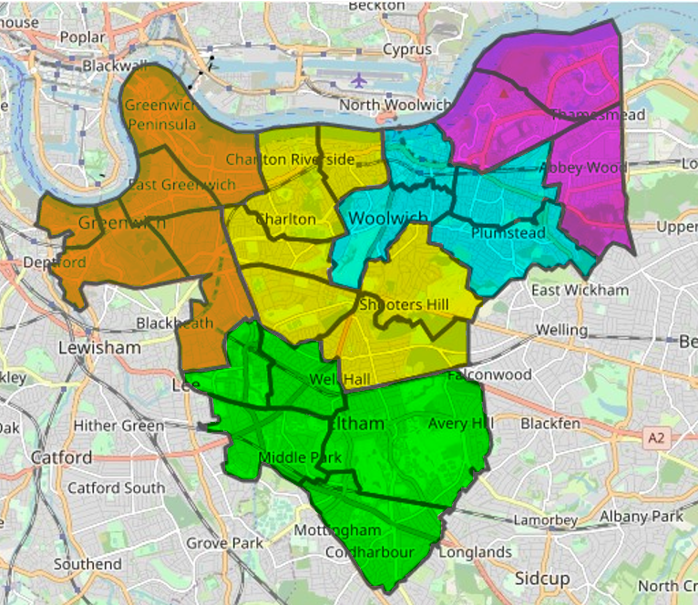  
Figure 1: Map of place-based Welcoming Space areas.

1.5 Lot two is for the provision of group-based Welcoming Spaces. A group-based Welcoming Space must cater to the needs of a specific group within the community, e.g., particular ethnic groups, groups with a shared identity, or who face similar barriers to social participation, such as people experiencing homelessness, or people with mental health difficulties.

1.6 Organisations must specify in their application form which lot they are applying for. Organisations can submit applications for both lots, but these must be separate applications for separate provision.

1.7 Organisations applying to either lot can open a Welcoming Space which spans across multiple venues, but this must be clearly stated in the application

1.8 In the event that we do not receive enough high-quality bids to be able to award to five organisations per lot, we reserve the right to approach organisations directly, or to negotiate with providers to ask them to cater to specific groups or communities.

1.9 For both lots, organisations are able to apply for grants between a minimum of £1,000 and a maximum of £9,950. Applications outside of these thresholds will not be considered.

1.10 There is a total of £100,000 to allocate as part of the Welcoming Spaces Grant, to a maximum of 10 providers.

1.11 The focus of the scheme is on supporting activities taking place in the winter months, from 1 November 2023 to 31 March 2024.

1. **Grant Overview**
   1. Grants are available to support groups to set up or expand existing Welcoming Spaces, as well as activities that encourage residents to come together.
   2. The following minimum requirements are a condition for any organisation to be considered for funding.

* Access to an appropriate venue, with enough room for a minimum of 15 visitors at any one time, meaning they can freely move around the space, have somewhere to sit, and access the venue’s amenities.
* The delivery of a minimum of 6 hours per week of Welcoming Space provision, to be delivered in one session or split throughout the week – we would encourage bids to consider hours during the evenings and weekends
* If planning to deliver food provision, compliance with requirements stated in paragraphs 2.6 to 2.8 of this document.
* The delivery of some form of activity or event throughout the week that is suitable for the attendees of the Space.
* The provision of basic amenities, such as adequate heating, adequate comfortable seating, free Wi-Fi, plug socket and light refreshments (e.g., drinking water, hot and cold drinks, fruit). The list of basic amenities is non-prescriptive, but we would expect all successful bids to meet a basic standard.
* The provision of advice and support to visitors. This could take multiple forms, for example signposting to specialist support services, employment support or support with accessing benefits, however this is not an exhaustive or prescriptive list.
* Willingness to facilitate the delivery of advice and signposting services by LiveWell Greenwich. This could include but may not be limited to:
  + Displaying posters in Welcoming Space sites and distributing leaflets to visitors
  + Facilitating a ‘roaming’ LiveWell advisor, who will visit periodically to speak to visitors and help them to access support.
  1. You cannot apply for:
* Contribution to core or pre-existing salaries.
* Activities that charge a fee to the general public.
* Activities that are not open to the general public.
* Activities that require prior signup and do not allow walk-ins.
* Activities that are already funded through existing contracts or agreements with the Royal Borough of Greenwich.
* Items which only benefit individuals (for example: equipment that is not shared)
* Activities promoting political activities or religious beliefs.
* Fundraising activities
* Projects which only benefit animals
* Funds to carry out capital improvements or maintenance to the building the Welcoming Space will be held in
* Retrospective payments for activities that have already taken place.
  1. Grant funding can be used for, but not limited to, the following areas:
* Providing space and/or support for resident led activities such as craft making or game playing (e.g. costs for room hire, materials etc)
* Extending opening times and support to enable people to re-charge devices or simply have a safe space to be in.
* Creating ‘work spaces’ for visitors, where they can log onto a computer and apply to jobs/ check emails
* Improving an existing space so more people can use the facility.
* Improving disabled access and facilities
* Covering energy costs involved in running a Welcoming Space, and/or energy efficiency measures to keep the space warm.
* Running costs including staffing or volunteer costs
* Provision of light refreshments, such as drinking water, hot or cold drinks, or fruit.
* More substantial food provision, such as community meals or hot food, provided you comply with the requirements stated in paragraphs 2.6-2.7 of this document.
* Anything else that enables the space to be open and welcoming.
  1. The aim of the Welcoming Spaces Grants Scheme is to achieve the following outcomes:
* Reduction in feelings of loneliness and isolation among attendees
* Increases in community cohesion and a sense of belonging among attendees
* Meaningful use of time, including access to activities that facilitate social connection
* Attendees are better able to keep themselves warm over winter
* Attendees have increased access to hot food and/ or drink
* Attendees given advice and/or support within the Welcoming Spaces
* Attendees signposted to third party specialist support by the Welcoming Spaces
* Attendees have improved capability and responsibility in accessing information, advice and support in the future.

**Food Requirements:**

* 1. If you are applying for a grant including food related activity, this must be in line with the principles of Good Food in Greenwich, where ‘good’ food means healthy, affordable, sustainable and culturally appropriate. You can demonstrate this commitment by signing up to the GFiG community charter or outlining how your proposal relates to it [www.goodfoodingreenwich.org/community-charter](http://www.goodfoodingreenwich.org/community-charter).

* 1. If you are applying for a grant including food related activity and you are handling, storing or preparing food then you must register as a food business and attain a food hygiene rating of 4 or above. Register with the Royal Borough of Greenwich as a food business by completing the [Food Business Registration form.](https://www.gov.uk/food-business-registration)
  2. Other requirements for food safety include:
* Have a completed food safety management system in place such as [Safer food, better business for caterers | Food Standards Agency](https://food.gov.uk/business-guidance/safer-food-better-business-for-caterers). This system must be on site, available and up to date at all times. This system must also include the arrangements for staff sickness including monitoring and reporting, and actions to be taken if the programme can no longer be delivered safely.
* Have a minimum of two staff with at least Level 2 food hygiene training within the organisation, this must be completed prior to a programme starting.
* Have a minimum of two staff with completed [Food Standards Agency allergen training](https://allergytraining.food.gov.uk/) prior to the programme starting.
* Have at least one dedicated supervisor on site at all times with respect to food safety. This member of staff must be fully trained to at least Level 2 in food hygiene and allergens.
* Ensure that all other staff and volunteers are trained and/ or supervised and instructed in food hygiene appropriate to the activity they are carrying out.
* Ensure information on allergens and ingredients is available at every programme, for every meal served. Where food is to be taken away, pre-packed for direct sale requirements will apply (Natasha’s Law), for more information see here <https://www.food.gov.uk/business-guidance/introduction-to-allergen-labelling-changes-ppds>
* Ensure that cultural food is handled correctly.

1. **Submission of Information**
   1. This section sets out what information must be provided as part of your bid. Please submit this on the application form which has been provided with this guidance.
   2. You must provide the following core information about your organisation:

* Organisation name
* Named contact for the proposal
* Postal address
* Address or location where the Welcoming Space(s) will be hosted
* Contact details
* Organisation / charity registered number.
* If you are an individual or un-constituted group, the details of your Sponsor Organisation including their organisation/ charity registered number.
* The primary aim of the organisation.
* Whether, and how long, the organisation has been operating in Royal Borough of Greenwich
* How much funding the organisation is applying for
* Which lot the organisation is applying for
* Details of any funding the organisation already receives from the Royal Borough of Greenwich
  1. You must provide the following organisational policies or procedures, or commit to providing them by the commencement of your provision:
* Public liability insurance
* Up-to-date adult safeguarding policy
* Up-to-date children’s safeguarding policy
* Up-to-date health and safety policy
* Up-to-date equality and diversity policy
* Risk assessment for Welcoming Spaces activity.
  1. You must provide the following information regarding your provision:
* Accessibility of your venue for residents with mobility needs and provision of accessible toilets
* The basic amenities your Space(s) provides
* The proposed opening hours of your Space(s)
* The number of visitors your Space(s) can accommodate at any one time
* Details of any other information that may be relevant (e.g., public transport links, parking, hearing induction loop, baby changing facilities)
  1. If you include food provision as part of your bid, you must provide the following information:
* Whether your organisation is registered as a food business with Greenwich at the venue(s) where you plan to deliver your Welcoming Space(s).
* If so, your Food Hygiene Rating Score.
* If not, whether you are committed to becoming registered before the commencement of your provision.
* Whether your organisation is registered with Good Food in Greenwich
* How your food provision links to the principles of the Good Food in Greenwich community charter (<https://www.goodfoodingreenwich.org/copy-of-hospitality>)
  1. You must also submit a proposal, which will be assessed to decide on your eligibility to receive funding. This must include:

**Project Aims**

* An outline of what will be delivered and how, including; the aims of the Welcoming Space(s), details of any planned activities, and how your proposal meets the aims of the funding.

**Resident needs needs**

* An overview of which residents you will be working with and their levels of need.
* If you are applying for Lot 1 (place based), how you will ensure your Welcoming Space(s) are inclusive to all.
* If you are applying for Lot 2 (group based), how you will ensure your Welcoming Space(s) meet the needs of the group you are intending to serve, whilst remaining inclusive for others in the community.

**Project Details**

* An overview of how you plan to advertise your Welcoming Space(s) to residents, including a brief communications plan.
* What is already in place to deliver your Welcoming Space(s) successfully, and what else needs to be established.
* Examples of similar services you have previously successfully delivered.

**Delivery timescale**

* This must include a brief project plan, outlining the key deliverables, milestones, and timescales for delivery of your Welcoming Space(s). This must be realistic, consistent with the parameters of the funding and deliver the funding aims.

**Budget**

* A budget outlining how much funding, between £1,000 and £9,550, you are bidding for and how you intend to spend the funding.

**Monitoring**

* A monitoring plan outlining how will you collect the monitoring data required as a condition of funding and report it back to the Council in a timely manner, as detailed in section 6 of this document.
* How you will measure and evaluate the impact of your provision on residents.

More details on how your bid will be assessed, and instructions on how to complete this information are given in the application form.

* 1. To submit a bid:

1. Download the application form from our website (Word document)
2. Read through the template and the scoring guidance
3. Fill in parts A, B, C, D and E using the blank boxes in the template.
4. Save your application form as a Word document and send it to [cost-of-living@royalgreenwich.gov.uk](mailto:cost-of-living@royalgreenwich.gov.uk). Please include the relevant procedures and evidence which is asked for in the application form.
5. The deadline for bids is 10am Wednesday 20th September. Any bids received after this date will not be considered for funding.
6. **Support Offer**
   1. All providers will be able to email any clarification questions prior to applying for funding irrespective of whether they request more in-depth support. These should be emailed to [Cost-of-Living@royalgreenwich.gov.uk](mailto:Cost-of-Living@royalgreenwich.gov.uk).
   2. We are running two workshops in partnership with MetroGAVS, where potential bidders can come to ask questions and receive support with their bids. These are scheduled for:

* Workshop 1: 14:00 -15:00 6th September
* Workshop 2: 10:30 – 11:30 7th September

Please email [Cost-of-Living@royalgreenwich.gov.uk](mailto:Cost-of-Living@royalgreenwich.gov.uk) for an invite to either of these workshops.

* 1. In recognition that some organisations may not be used to submitting bids for funding there are two different support options available.
  2. The borough’s VCS infrastructure body MetroGAVS are well placed to offer local voluntary organisations a range of support, advice and information on matters concerning fundraising, including help with all aspects of bid writing and securing a venue for a Welcoming Space.
  3. MetroGAVS can be contacted as follows: Email: [gavs@metrocharity.org.uk](mailto:gavs@metrocharity.org.uk) / 020 8305 500 0
  4. The Council’s dedicated Voluntary and Community Sector Team can offer advice and support with completing your application. Please email [VCS-grants@royalgreenwich.gov.uk](mailto:VCS-grants@royalgreenwich.gov.uk)
  5. If you would like information on warm spaces, you can access Martin Lewis’s guidance on setting up a warm space here: [a_warm_welcome_2022.pdf (ymaws.com)](https://cdn.ymaws.com/cilip.site-ym.com/resource/resmgr/cilip/information_professional_and_news/press_releases/2022_10/a_warm_welcome_2022.pdf)
  6. Information regarding wider support the borough is offering residents, and local organisations and businesses during the cost-of-living crisis is available here: <https://www.royalgreenwich.gov.uk/Greenwich-Supports>
  7. If you plan to include food in your provision, you can find out more about Good Food in Greenwich and the principles of good food catering by visiting [www.goodfoodingreenwich.org](http://www.goodfoodingreenwich.org) or emailing [info@goodfoodingreenwich.org](mailto:info@goodfoodingreenwich.org).
  8. All providers will receive the following support with promoting and communicating their Welcoming Space offer to residents and communities:
* MetroGAVS offer a range of communications support, including adding information about Welcoming Space provision to their email bulletins and using their wide reach within the VCS in Greenwich.
* The Council will promote information on Welcoming Spaces and signpost residents via official messaging on its website and other channels, including our Welcoming Spaces Map: <https://www.royalgreenwich.gov.uk/info/200344/supporting_you/2412/warm_spaces_and_support_in_royal_greenwich>
* The Council will also provide an asset pack, with templates including posters, leaflets and art that organisations can use to promote their Welcoming Spaces.

1. **Individual and Un-constituted Groups, and Groups without their own Venue** 
   1. If you are applying for a grant as an individual or un-constituted group, you will need a Sponsor Organisation. Sponsor Organisations could be community or voluntary organisations, faith institutions and/or other constituted groups. Support to find a sponsor will be provided if required.
   2. If you are interested in hosting a Welcoming Space but do not have your own space, please contact MetroGAVS for support to find a venue in Greenwich to meet your requirements.
2. **Monitoring information** 
   1. The funding for the Welcoming Spaces Grants is provided through the Department of Work and Pensions’ Household Support Fund, which imposes monitoring requirements on the Council. As such, successful bidders must capture the following quantitative information in the delivery of their bid:

* The number of visitors to the Welcoming Space(s)
* The number of visits (footfall) to the Welcoming Space(s)
  1. Successful bidders must also capture qualitative information, in the form of visitor feedback surveys and service user case studies, to allow the Council to monitor the success of the Welcoming Spaces grant programme and demonstrate the impact it has had.
  2. Successful bidders will be required to submit monitoring data on a monthly basis using templates provided by the Council.
  3. Successful bidders will receive 90% of the grant during the mobilisation process. The remaining 10% will be withheld until after the provision has completed and the organisation has completed and returned all required monitoring information.
  4. The Council reserves the right to conduct unannounced quality assurance visits on all provision.

1. **Evaluation**
   1. Only proposals submitted prior to the timescales set out in section 8 and valued at between £1,000 and £9,950 will be accepted.
   2. The proposals submitted will be evaluated against the requirements set out in this document.
2. **Timetable** 
   1. The table below sets out the key dates for this funding opportunity:

|  |  |
| --- | --- |
| **Milestone** | **Date** |
| Applications open | 23rd August 2023 |
| Online bid writing workshop | 6th September 2023 14:00-15:00 |
| Online bid writing workshop | 7th September 2023 10:30-11.30 |
| Deadline for clarifying questions | 15th September 2023 12:00 |
| Submission of final bid to [Cost-of-living@royalgreenwich.gov.uk](mailto:Cost-of-living@royalgreenwich.gov.uk) | 20th September 2023 10:00 |
| Allocation process | Applications will be considered by officers after the closing date |
| Confirmation of bid | 21st October 2023  If successful, your project must mobilise within one month of funding being received. |