LEE FORUM
Application for designation of neighbourhood area and neighbourhood forum

This is an application for the redesignation of Lee Forum as the relevant body for the purposes of neighbourhood planning in the Lee neighbourhood area. Lee Forum are local volunteers. Further details of who Lee Forum are and their work can be read here.

The proposed neighbourhood area includes land in both Lewisham and Greenwich London Boroughs. This application is being made to each local authority for the purposes of creating a single neighbourhood area and forum.

The area and Lee Forum as it’s relevant body were first designated by Lewisham and Greenwich London Boroughs in January 2016. Since that date Lee Forum has carried out three area-wide consultations and many smaller consultations and workshops. Details of these activities can be read in this consultation statement. Lee Forum have also been drafting a detailed Neighbourhood Plan for the Lee Forum area which is now post section 14 Consultation and can be read here. It is the intention that once this version of the neighbourhood plan has been reviewed by the Boroughs and an independent examiner and been further consulted on, amended as needed, and put to a referendum to the local population, that it be adopted by the Boroughs in order to guide future development in the Lee area.

Regulation 5 of Part 2 of the Neighbourhood Planning (General) Regulations 2012 requires that our application includes:
i. a map identifying the boundaries to which the area application relates – see Schedule A
ii. a statement that the organisation or body making the area application is a qualifying body for the purposes of section 61G of the 1990 Act – see Schedule C.

Regulation 8 of Part 3 of the Neighbourhood Planning (General) Regulations 2012 requires that for us to be considered as a Neighbourhood Forum our application must include:
i. our name: This will be Lee Forum.
ii. our constitution: This is attached at Schedule D
iii. support from at least 21 individuals who live or work in the area: This is attached in Schedule E
iv. the name of the area to which the application pertains: This will be ‘Lee’.
v. the contact details of at least one member of the proposed forum: This is as follows:
- Sarah McMichael, info@leeforum.org.uk
This application has been prepared following consultation and engagement with interested people and organisations across the proposed neighbourhood area. Details of this engagement are included in Schedule F.

SCHEDULE A
Map of the Lee Forum area

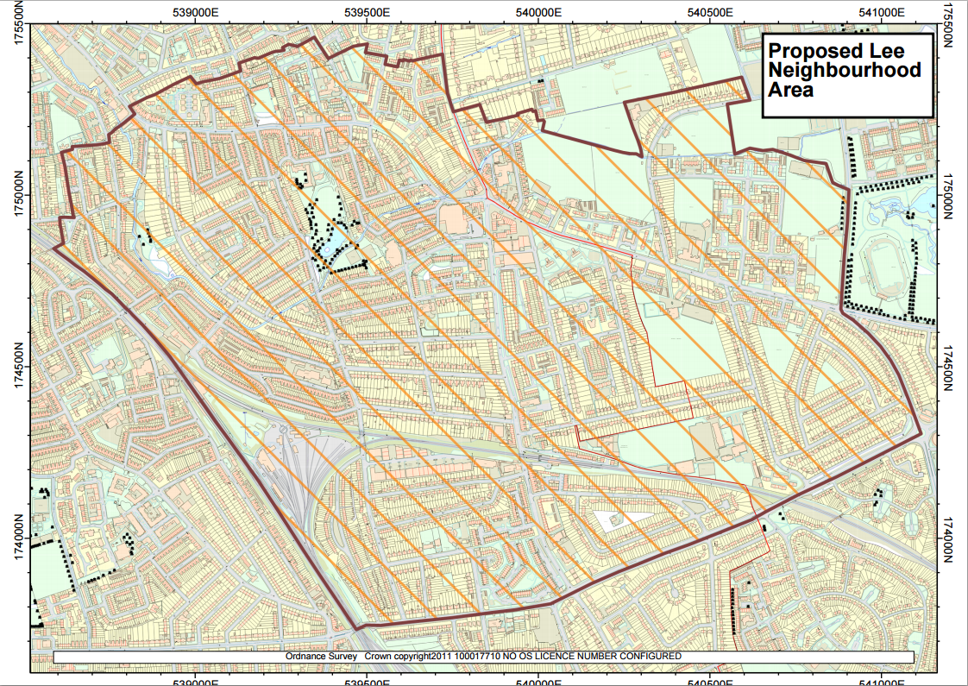

SCHEDULE B (NOT RELEVANT TO APPLICATION)
SCHEDULE C
Statement regarding Lee Forum as a “qualifying body”
The application is being made by the proposed Neighbourhood Forum. Within the terms of the Localism Act and its subsequent regulations, we may be considered as a qualifying body to seek the designation of the Lee Forum area as a Neighbourhood Area by virtue of the fact that we are capable of being designated a Neighbourhood Forum because:
a) The express purpose of the Forum is to promote or improve the social, economic and environmental well-being of the neighbourhood area.
b) Our membership is and will remain open to:
i. individuals who live in the area
ii. individuals who work in the area, whether for business carried on there or otherwise;
iii. community organisations which operate in the area, through their duly appointed representatives
iv. businesses, educational establishments or other entities which operate in the neighbourhood area, through their duly appointed representatives
v. individuals who are elected members of local authorities, any part of which falls within the Area, who shall be ex officio members
vi. individuals who have a material and ongoing social, cultural, economic or financial interest in or involvement in the area

c) Our membership will include a minimum of 21 individuals drawn from different parts of the area and different communities.

d) We have a written constitution (see Schedule D).

SCHEDULE D
Constitution of Lee Forum

1. Name

The name of the organisation is the Lee Forum (“the Forum”).

2. Purpose

a. The purpose of the Forum is to promote and improve the social, economic and environmental well-being of the neighbourhood area. It shall operate without distinction or discrimination on the grounds of gender, disability, sexual orientation or race, or of political, religious or other beliefs.

b. The Forum will achieve this by:
- actively encouraging all the Members to participate in the activities of the Forum for the promotion and improvement of the area
- creating a Neighbourhood Plan, giving due recognition to the complementary relationship between the Neighbourhood Plan and any plan already adopted by any relevant local group, and, in each case, taking account of applicable parts of those plans
- considering the appropriateness and relevance to the area of taking advantage of the other rights afforded to forums under the Localism Act 2011 and supplementary regulations
- improving and supporting cross border planning and processes in the area
- collaborating with existing local groups in the neighbourhood area which are relevant to the Forum’s purpose and taking account of their interests, preferences and views
- supporting projects and other activities that are of benefit to the area
- providing a forum for discussion of issues that may affect the cross-ward and cross-borough area for generating ideas and proposals to enhance it.
3. Area

a. The Forum shall cover the area shown in the attached map, subject to any amendment as may be agreed with Lewisham and Greenwich Councils, acting in their capacities as Local Planning Authority.

b. The Lee Neighbourhood Forum’s area of interest includes land within the London Boroughs of Lewisham and Greenwich and the wards of Lee Green, Sutcliffe & Middle Park and Blackheath.
4. Membership

a. Membership is open to all those who provide contact details for use by the Forum and who fall into one or more of the following categories:
i. all individuals who live in the area
ii. all individuals who work in the area, whether for business carried on there or otherwise
iii. all community organisations which operate in the area, through their duly appointed representatives (the term community organisation includes conservation societies, parks and special buildings or amenities user groups, charities, churches and other religious establishments, welfare organisations and other bodies which operate wholly or partly within the area and whose aims are consistent with the purpose of the Forum)
iv. businesses, educational establishments or other entities which operate in the area, through their duly appointed representatives
v. elected representatives from each local authority ward, the whole or part of which falls within the area, as ex officio members
vi. individuals who have a material and ongoing social, cultural, economic or financial interest in or involvement in the area who support the purpose of the Forum and provide the Secretary with satisfactory evidence of eligibility
b. The Management Committee may refuse to accept, or may revoke, membership of any individual or organisation which in its opinion fails to meet the criteria for membership or which acts in a way inimical to the forum’s purpose. Any person or organisation whose membership is revoked shall have the right to appeal to a General Meeting of the Forum.

5. Management Committee and Officers

a. The day-to-day business of the Forum shall be conducted by the Management Committee (“the Committee”). Subject to decisions of any General Meeting, the Committee shall comprise up to 15 members elected by a General Meeting. The Forum shall strive for the Committee to reflect the diversity of people eligible for membership. In particular every effort shall be made to include:
i. at least one person aged under 30
ii. members from local businesses
iii. at least one person from each of the tenure groups: owner-occupier, tenant of the local authority or registered social landlord and private tenant
iv. members who are women
v. members who are men
vi. ethnic minority members
vii disabled members
viii at least two people from each of the wards which is included in whole or part within the forum

b. Councillors or others elected to public office for any part of the neighbourhood area shall not be eligible for election, but one from each ward which is included wholly or partly in the forum area may be co-opted to the Committee under paragraph 5.d

c. The term of office of any member of the Committee shall expire at each AGM and members shall be eligible to stand for re-election for up to a maximum of five years.

d. The Committee may co-opt up to five additional voting members for a term to expire no later than the following AGM. The power of co-option shall be used inter alia to ensure that as far as possible the Committee has a reasonable balance and reflects the local community.

e. The Committee shall elect from among its members a Chair, Secretary, Treasurer, Media Officer and other officers as it sees fit.

f. The Committee shall meet at least three times per year and five members (including at least one of the officers named in 5.) shall constitute a quorum.

g. The Committee may appoint groups to carry out specific roles or projects as it sees fit and shall co-opt such persons as necessary to enable any such group to perform its function.

h. Decisions of the Committee shall be by consensus or by a simple majority of those present. If required the Chair will have a casting vote.

i. The decision on the content of a proposed neighbourhood plan shall be subject to agreement at a General Meeting of the Membership.

j. The Committee shall record its proceedings which shall be publicly available.

k. Forum members who are not Committee members may request to attend Committee meetings through application to the Secretary. Permission to attend and speak will be granted at the discretion the Chair.

l. The Committee will elect the following officers of the Forum from its numbers (positions may be shared and tasks divided amongst them): Chair, Secretary and Treasurer

The Chair of the Forum Committee shall be responsible for:
- Chairing meetings of the Management Committee and General Meetings of the membership
- Exercising a casting vote on elections and resolutions at meetings of the Forum and its Management Committee
- Taking decisions on urgent matters between meetings of the Management Committee, which will be reported to the following meeting.

The Treasurer shall be responsible for:
- Establishing a bank account and acting as a joint signatory on the account with one other member of the Management Committee
- Maintaining the Forums’ financial records
- Setting out a draft budget in the first year, and advising the Forum on staying within its budget
- Preparing and presenting annual accounts, at the Forum’s Annual General Meeting and arranging an independent examination of the accounts if the turnover exceeds £5,000
- providing a financial update at each meeting of the Management Committee.

The Secretary shall be responsible for:
  - Calling and organising the Forum’s Management Committee and General Meetings
  - Ensuring the provision of a record of Forum meetings and making these publicly available
  - Maintaining a register of Forum members.

6. Management Committee Code of conduct

a. The role of the Management Committee is to conduct the day to day business of the Forum in an efficient, fair and responsive way. In taking decisions on behalf of the Forum, Committee members must always be aware of their responsibility to all those living and working in the Forum area.
b. All Committee members must comply with this constitution and code of conduct at all times.
c. Committee members should conduct themselves in a manner which respects the views of others. Racist, sexist, personalised or inflammatory comments are not acceptable.
d. Committee members must abide by collective decisions made and always represent the Forum in a positive manner.
e. Committee members must never use their position to seek preferential treatment for themselves, relatives or members of their household. Any pecuniary or non-pecuniary interests must be declared at Committee meetings.
f. Committee members cannot receive any payment from the Forum, other than for bona fide expenses as approved by the Treasurer and submitted and recorded in writing.
7. General Meetings

a. The Annual General Meeting (AGM) of all members shall be the controlling body of the Forum.

b. An AGM shall be held on a day to be appointed by the Committee not later than three months after the end of the Forum’s financial year.

c. The business of the AGM shall include:
i. a report from the Chair on the activities of the Forum since the previous AGM and its plans for the forthcoming year
ii. a report from the Treasurer as to the financial position of the Forum
iii. consideration of and, if thought fit, approval of the accounts of the Forum for the previous financial year together with an independent examination of those accounts if the turnover exceeds £5,000 for the relevant year
iv. appointment of an independent examiner to report to the following AGM on the accounts for the current financial year if the turnover is forecast to exceed £5,000 for the relevant year
v. consideration of any motion which has been submitted by at least 10 members of the Forum in time for circulation with the notice of the AGM
vi. election of the Committee for the forthcoming year
vii. any other business as required by the Constitution or as directed by the Committee.

d. The Secretary shall give all members at least 21 days written notice of the time and place of the AGM. Such notice shall include details of all business to be transacted at the meeting.

e. Nominations for election to the Committee shall be invited in advance of the AGM and must be proposed and seconded in writing by members with the signed consent of the candidate. Nominations shall be duly submitted to the Secretary of the Forum not less than 3 days prior to the date of the AGM.

f. Election of members of the Committee may be taken by a show of hands of members or if requested by a majority of those members present by a ballot of those present at the AGM. Voting shall be by ranking the candidates in order of preference and shall be counted by the Single Transferable Vote method. The meeting shall agree to the appointment of one or more scrutineers to act as returning officers and to advise the Chair on the results.

g. A member shall be entitled to appoint a proxy to vote on his or her behalf. Notice of appointment of a proxy must be received by the Secretary not less than 24 hours before the meeting.

h. The AGM may, by a vote of not less than two-thirds of those members present, agree to consider any urgent or important business which has arisen since dispatch of the notice of the meeting.

i. The Management Committee shall have power to call an General Meeting as necessary (for example to approve a draft Plan).

j. Other General Meetings of all members shall be called within 28 days of receipt by the Secretary of a request in writing signed by no less than 21 members, stating the purpose for which the meeting is required or when directed by the Management Committee.

k. 21 members (or one-fifth of the membership if fewer) shall constitute a quorum at a General Meeting.

l. Voting at General Meetings shall be by show of hands of members, except as provided in paragraph 6.f. for election of Committee members

m. A record of each General Meeting shall be produced and made publicly available.

n. Conflicts of interest must be declared. Members with a conflict of interest should withdraw from discussion and voting on the issue in question.

8. Finance

a. The Forum’s accounting period shall be annual

b. Accounting records shall be maintained for a period of six years. On winding up the Forum such records shall be kept for two years. Records shall be available for inspection by any member on giving not less than 10 days notice.

c. The Forum shall open and maintain a bank or other appropriate account in the name of the Forum which shall be controlled by a mandate requiring the signature of the Treasurer and one other Management Committee member.

d. The Forum’s accounts shall be made publicly available within three months of the Forum’s financial year end.

e. The Forum may raise funds by donation, grants, or other means to be used in furtherance of the Forum’s purpose.

9. Constitution and Interpretation

a. In the event of any question arising where the interpretation of this Constitution is in doubt or where it is silent, the Committee shall have the power to act according to its own interpretation and at its discretion.

b. Other than as may be required by law, amendments to this Constitution may only be made by a majority representing at least two-thirds of the members present and voting at a quorate General Meeting.

c. Any requirement in this Constitution for notices or reports to be distributed to members of the Forum shall be deemed to have been satisfied if such notice or reports have been sent to all members by e-mail, by posting on the Forum’s website or by other electronic means. An individual member may request hard copies and in such a case the Committee reserves the right to make a charge to cover the extra cost incurred, with appropriate dispensation and regard for disability requirements.

10. Term

a. The duration of the Forum shall be for five years from the date of adoption of this Constitution unless it is previously wound up or extended by resolution at a General Meeting.

b. In the event of dissolution of the Forum any remaining assets shall be distributed to the community organisations which remain as members at that date in proportions to be decided by the Committee, which shall retain responsibility for completing such distribution for a period ending six months from the date of dissolution.

SCHEDULE E

Supporter details

For designation of neighbourhood area and neighbourhood forum
Name | Borough | Ward | Road & Postcode | Resident, Business, other |  | Total
Imogen Solly | Lewisham | Lee Green | SE12 8NZ | Resident
Pat Richardson | Lewisham | Lee Green | SE13 5QL | Resident
Peter Richardson | Lewisham | Lee Green | SE13 5QL | Resident and Chair of Users and Friends of Manor House Library
Rozina Visram, | Greenwich | Middle Park and Sutcliffe | SE12 8JA | Resident
Sheila Peck | Lewisham | Lee Green | SE12 8QF | Resident
Diana Stevenson | Lewisham | Lee Green | SE12 8PZ | Resident
Francis Thompson | Greenwich | Middle Park and Sutcliffe | SE12 8AP | Resident
Alison Mckinley | Greenwich | Middle Park and Sutcliffe | SE12 8UW | Resident
Garard Carty | Greenwich | Middle Park and Sutcliffe | SE12 8UW | Resident
Gill Stoker | Lewisham | Lee Green | SE12 8DT | Resident
Sarah McMichael | Lewisham | Lee Green | SE12 8LX | Resident
Marietta Stankova | Lewisham | Lee Green | SE13 5QP | Resident
Julie Williams | Lewisham | Lee Green | SE12 8EA | Resident
Jo Smith | Lewisham | Lee Green | SE13 5TA | Resident
Oliver Crispin | Lewisham | Lee Green | SE13 5TA | Resident
Bridget Shepherd | Lewisham | Lee Green | SE12 8NR | Resident and vicar, Church of Good Shepherd and St Peters
Jean Lindsay | Lewisham | Lee Green | SE13 5SX | Resident
Richard Cains | Greenwich | Middle Park and Sutcliffe | SE12 8JN | Resident and Chair of Courtland Estate Residents Group
Anne Lewis | Lewisham | Lee Green | SE13 5RA | Resident and recent Chair of FUSS
David Ford | Lewisham | Lee Green | SE12 9JA | Resident
Jan Ford | Lewisham | Lee Green | SE12 9JA | Resident
Grant Herbert | Lewisham | Blackheath | SE3 9DE | Business owner,  122 Hairdressers
Hilary Levers | Lewisham | Lee Green | SE12 8NZ | Resident
Katty Morgan | Lewisham | Lee Green | SE13 5QL | Resident
Katie Whitehead | Lewisham | Blackheath | SE13 55F | Resident
Lucy Anne Bishop | Lewisham | Blackheath | SE3 9DE | Resident
Jo McCrone | Lewisham | Lee Green | SE13 5RG | Resident
Clare Lusted | Greenwich | Middle Park and Sutcliffe | SE128HG | Resident
Nicolette Duckham | Lewisham | Lee Green | SE13 5HW | Resident
Leonard Kenny | Greenwich | Middle Park and Sutcliffe | SE12 8JJ | Resident
Carole Hicks | Lewisham | Lee Green | SE13 5RA | Resident
Peter Cleary | Greenwich | Middle Park and Sutcliffe | SE12 8JA | Resident
Total |  |  |  |  |  | 31

SCHEDULE F (NOT RELEVANT TO APPLICATION)

